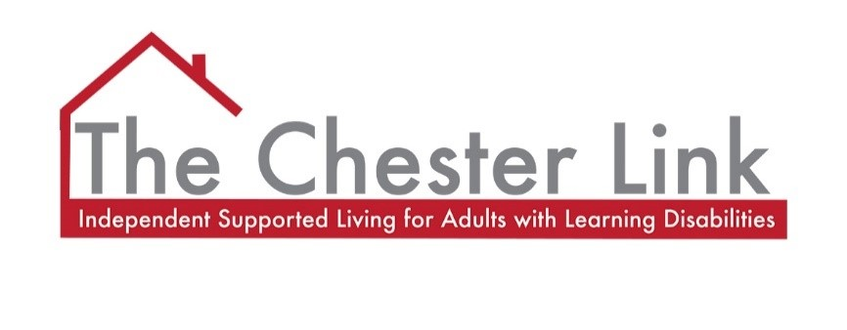

PRIVACY NOTICE - COMPANY

DOCUMENT NAME | Privacy Notice – Company
POLICY NUMBER | D4c
NEXT REVIEW DATE | July 2026
POLICY AUTHOR | Anna Maclese
REVIEWED BY | Charlotte Bunton-Deer
DATE RATIFIED | July 2023
RATIFYING BODY | Chester Link Management Committee
VERSION NUMBER | 3
THIS DOCUMENT SHOULD BE READ IN CONJUCTION WITH: | D1 Data Protection Policy  D4 Record Keeping and Privacy Notice Policy  D4a Privacy Notice - Service Users  D4b Privacy Notice – Service Users Easy Read

Data Protection Privacy Notice - Company

Chester Link is committed to protecting the privacy of individuals in compliance with the General Data Protection Regulations (25.05.2018) and UK Data Protection legislation. This notice explains how and why we use personal data.
Chester Link also have a section of Data Protection Policies which consists of Record Keeping, Bring Your Own Device sets out the organisation’s principles and standards for data protection.

About us
We are Chester Link, a charity registered in England and Wales (Company Number 3267791) with its office at 10 St John Street, Chester, Cheshire, CH1 1DA. We are listed on the Information Commissioner’s register of data controllers under number: ZA009822.
Chester Link is the ‘data controller’ for the purpose of data protection law. As the ‘data controller’ we are responsible for deciding how we hold and use personal data.

What information we collect and why
If you are a service user, family member, employee, trustee of Chester Link or a supplier of goods or services we collect personal data about you such as your name, address, telephone numbers, email address and emergency contacts. In the case of service users and employees we also hold sensitive personal data to provide our services to you or deliver the contract we have with you, this information may relate to your bank account details and medical information. We take extra care to ensure that this data is protected.
We also process sensitive personal data in an official capacity for the purpose of undertaking criminal records checks in the recruitment of staff working with vulnerable adults. This data is protected by additional safeguards laid out in legislation.

How we use your information
Chester Link will only ever use your personal data to the extent necessary to
- Perform a contract with you,
- Comply with a legal duty,
- Undertake our own legitimate business interests provided your rights don’t override these.
Information will only be used for the purpose it was collected. We may process your personal data for more than one of the lawful reasons stated above depending on the specific purpose for which we are using your data. For our service users this includes using your personal and sensitive data to the extent necessary to perform our contractual and legal obligations such as providing you with care and support services. There may from time to time be reasons of legitimate business interest to use your data.

For our employees your data will be used only for contractual, legal or legitimate business purposes. It will be shared to ensure you are paid and to meet ours and your legal employment obligations such as providing information to the HMRC. We will never share your personal or sensitive data with a third party who might use it for their own purposes.
Where you supply goods or services to us your personal data will be used arising from any agreements entered with Chester Link and to carry out our legal obligations.
Chester Link does not use personal data for any direct marketing activities and no personal data is collected on our web site. However, in limited circumstances you may have provided your consent to the holding of your personal data to receive our newsletter. You have the right to withdraw this consent and can do so by contacting the nominated Data Protection Person as detailed below.

Security of your information
Keeping your data safe is of paramount importance to us. We have in place a variety of reasonable and appropriate technical and organisational measures to ensure that it is protected from accidental loss, unauthorised access, use or disclosure of it.
Chester Link has completed a Data Security and Protection Toolkit self-assessment to demonstrate it is practising good data security and that personal information is handled correctly.
In the event of any suspected data security breach this will be immediately investigated and rectified. We will notify you and the Information Commissioner’s Office (ICO) of a suspected breach where we are legally required to do so.

Data sharing
Chester Link has legal obligations to share personal data with third parties such as HMRC where there are legitimate interests or contractual reasons to do so.
When it is necessary to share your data with another organisation who provide a service to us such as our payroll provider and banking services, they are required by law to take reasonable and appropriate steps to ensure that your personal and sensitive data is secure. We only permit our third party providers to process your personal data for specified purposes and in accordance with our instructions.
We will at all times limit access to your personal data on a strict business need to know basis. We will never share your personal or sensitive data with a third party who might use it for their own purposes.
Your information is not shared outside the UK, unless for sponsorship for a skilled worker, with their consent.

Data retention
We will retain information for as long as an individual has a contract of service or employment or a business service with us. Data will be accurate, kept up to date, relevant and limited to what is necessary. After the contract or service provision has ended necessary data will be archived to comply with legal requirements and those of the Care Quality Commission.
Data retention will be reviewed annually, and data will be kept for no longer than necessary.

Your rights
Under data protection law you have the right to be informed about the processing of your personal data. Also, you have the right to ask to see the information we hold about you and be able to amend it if the information is inaccurate or incomplete. You have the right to request erasure, but this is not an automatic right and only applies where there is no lawful reason for us to continue to process the data. Under certain circumstances you may also have the right to object or restrict processing and transfer your personal data. If you want to exercise any of your rights’, please contact out Data Protection Person named below.
It is important that the personal data we hold about you is accurate and current. In the event that your personal information changes please notify us of any relevant changes by contacting Chester Link’s nominated Data Security and Protection Lead or their deputy as below.

Subject access request
If you make a request to access your personal data, this is known as a Subject Access Request (SAR). A request can be made verbally or in writing, but it must be specific and made for data protection purposes. This will be dealt with without undue delay and at the latest within one month.
Provided the request is reasonable no fee will be charged.
We take all necessary steps to ensure that personal information is not disclosed to any person who has no right to receive it. If you make a SAR, we will confirm your identity and ensure your right to access the information or to exercise any of your other rights.

Nominated data protection person
Chester Link’s Data Security and Protection Lead is the point of contact for data protection and any queries or requests for information should be addressed to Anna Maclese at the organisation’s address or email anna.maclese@chesterlink.co.uk in their absence any queries or requests should be directed to their deputy, Charlotte Bunton-Deer charlotte@chesterlink.co.uk

Complaints
You have the right at any time to make a complaint to the ICO, the UK regulatory for data protection. You can find out more information on the ICO website https://ico.org.uk/concerns.
The ICO’s contact details are as follows:
Information Commissioner’s Office
Wycliffe House
Water Lane
Wilmslow
Cheshire
SK9 5AF

Telephone number: 0303 123 1113 (local rate) or 01625 545 745 (national rate)

